### Semester One Examination, 2016

### Question/Answer Booklet

# MATHEMATICS

**SOLUTIONS**

**METHODS**

**UNIT 1**

## Section Two:

## Calculator-assumed

|  |  |  |  |  |  |  |  |  |
| --- | --- | --- | --- | --- | --- | --- | --- | --- |
| Student Number: In figures |  |  |  |  |  |  |  |  |

In words

Your name

## Time allowed for this section

Reading time before commencing work: ten minutes

Working time for section: one hundred minutes

## Materials required/recommended for this section

***To be provided by the supervisor***

This Question/Answer Booklet

Formula Sheet (retained from Section One)

***To be provided by the candidate***

Standard items: pens (blue/black preferred), pencils (including coloured), sharpener, correction fluid/tape, eraser, ruler, highlighters

Special items: drawing instruments, templates, notes on two unfolded sheets of A4 paper, and up to three calculators approved for use in the WACE examinations

## Important note to candidates

No other items may be taken into the examination room. It is **your** responsibility to ensure that you do not have any unauthorised notes or other items of a non-personal nature in the examination room. If you have any unauthorised material with you, hand it to the supervisor **before** reading any further.

## Structure of this paper

|  |  |  |  |  |  |
| --- | --- | --- | --- | --- | --- |
| Section | Number of questions available | Number of questions to be answered | Working  time (minutes) | Marks available | Percentage of exam |
| Section One:  Calculator-free | 7 | 7 | 50 | 50 | 35 |
| Section Two:  Calculator-assumed | 13 | 13 | 100 | 99 | 65 |
|  | | | **Total** | 149 | 100 |

## Instructions to candidates

1. The rules for the conduct of examinations are detailed in the school handbook. Sitting this examination implies that you agree to abide by these rules.
2. Write your answers in this Question/Answer Booklet.
3. You must be careful to confine your response to the specific question asked and to follow any instructions that are specified to a particular question.
4. Spare pages are included at the end of this booklet. They can be used for planning your responses and/or as additional space if required to continue an answer.

* Planning: If you use the spare pages for planning, indicate this clearly at the top of the page.
* Continuing an answer: If you need to use the space to continue an answer, indicate in the original answer space where the answer is continued, i.e. give the page number. Fill in the number of the question that you are continuing to answer at the top of the page.

1. **Show all your working clearly**. Your working should be in sufficient detail to allow your answers to be checked readily and for marks to be awarded for reasoning. Incorrect answers given without supporting reasoning cannot be allocated any marks. For any question or part question worth more than two marks, valid working or justification is required to receive full marks. If you repeat any question, ensure that you cancel the answer you do not wish to have marked.
2. It is recommended that you **do not use pencil**, except in diagrams.
3. The Formula Sheet is **not** to be handed in with your Question/Answer Booklet.

Section Two: Calculator-assumed 65% (99 Marks)

This section has**thirteen (****13)** questions. Answer **all** questions. Write your answers in the spaces provided.

Working time for this section is 100 minutes.

Question 8 (6 marks)

The results from a clinical study on the effect of sleep on reaction times for a group of 210 male police cadets is shown in the table below. The participants were given either 4, 6 or 8 hours' sleep, woken and immediately asked to perform a series of tasks involving reacting to various stimuli, from which the total reaction time was calculated.

|  |  |  |
| --- | --- | --- |
|  | Total reaction time less than 3 s | Total reaction time 3 s or more. |
| Tested after 4 h sleep | 18 | 55 |
| Tested after 6 h sleep | 21 | 49 |
| Tested after 8 h sleep | 22 | 45 |

(a) Determine the probability that a randomly chosen participant

(i) had a total reaction time of less than 3 s. (1 mark)

|  |
| --- |
| **Solution** |
|  |
| **Specific behaviours** |
| ✓ determines probability |

(ii) was tested after 8 h sleep and had a total reaction time 3 s or more. (1 mark)

|  |
| --- |
| **Solution** |
|  |
| **Specific behaviours** |
| ✓ determines probability |

(b) Determine the probability that a randomly chosen participant had a reaction time of less than 3 s given they were woken after

(i) 4 h sleep. (1 mark)

|  |
| --- |
| **Solution** |
|  |
| **Specific behaviours** |
| ✓ determines probability |

(ii) 8 h sleep. (1 mark)

|  |
| --- |
| **Solution** |
|  |
| **Specific behaviours** |
| ✓ determines probability |

(c) Does the study suggest that reaction time is independent of sleep? Explain your answer.

(2 marks)

|  |
| --- |
| **Solution** |
| No - the probability of a faster reaction time changed from 0.25 to 0.33 as length of sleep increased, suggesting that not independent. |
| **Specific behaviours** |
| ✓ states no  ✓ supplies reason based on answers to (b) |

Question 9 (7 marks)

The graphs of the functions,  and  are shown below, where a, b, c, d, m and n are positive constants.

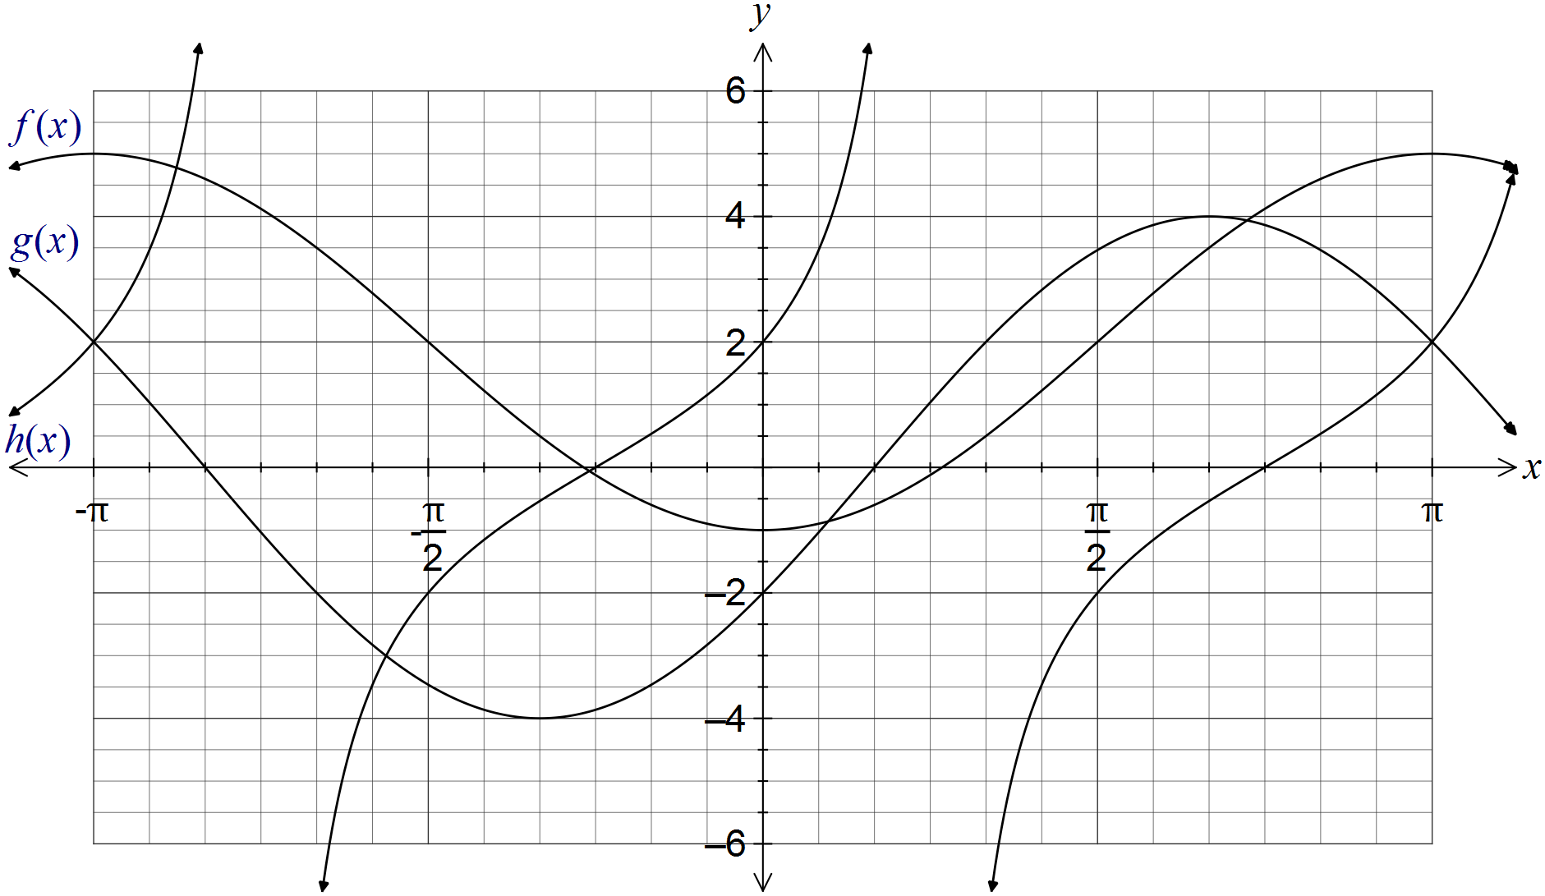

(a) Clearly label each of the functions f, g and h on the graph. (1 mark)

(b) Determine the values of the positive constants a, b, c, d, m and n. (6 marks)

|  |
| --- |
| **Solution** |
| Cos function has max value of 5, min of -1 and starts at min. .  Sin function has amplitude of 4 and first root at . .  (Strictly, )  Tan function: Root at , and midway between root and asymptote, .  (Strictly, ) |
| **Specific behaviours** |
| ✓ award one mark per value |

Question 10 (7 marks)

When a box of three fragile glasses is sent through the post, the probability that none of the glasses break is $\frac{1}{2}$, that one breaks is $\frac{7}{20}$ and that two break is $\frac{3}{25}$.

(a) Determine the probability that

(i) at least one glass breaks. (1 mark)

|  |
| --- |
| **Solution** |
|  |
| **Specific behaviours** |
| ✓ obtains correct probability |

(ii) fewer than two glasses break. (1 mark)

|  |
| --- |
| **Solution** |
|  |
| **Specific behaviours** |
| ✓ obtains correct probability |

(iii) exactly three glasses break. (1 mark)

|  |
| --- |
| **Solution** |
|  |
| **Specific behaviours** |
| ✓ obtains correct probability |

(b) During one week, a large number of boxes were sent, resulting in 280 customers receiving a box with one broken glass. Estimate how many boxes were sent during the week. (2 marks)

|  |
| --- |
| **Solution** |
|  |
| **Specific behaviours** |
| ✓ writes equation  ✓ solves to obtain estimate |

(c) After improvements were made to the packaging used, a random sample of 350 posted boxes were examined, of which just 11 contained all broken glasses. Briefly discuss whether there is any evidence that the improvements were successful. (2 marks)

|  |
| --- |
| **Solution** |
| - no evidence, the proportion broken is still very close to 0.03. |
| **Specific behaviours** |
| ✓ calculates relative frequency  ✓ concludes no evidence |

Question 11 (7 marks)

A function is defined by .

(a) State the domain of this function. (1 mark)

|  |
| --- |
| **Solution** |
|  |
| **Specific behaviours** |
| ✓ states domain restriction |

(b) Draw the graph of  on the axes below, clearly showing the coordinates of all axis-intercepts and equations of any asymptotes. (4 marks)

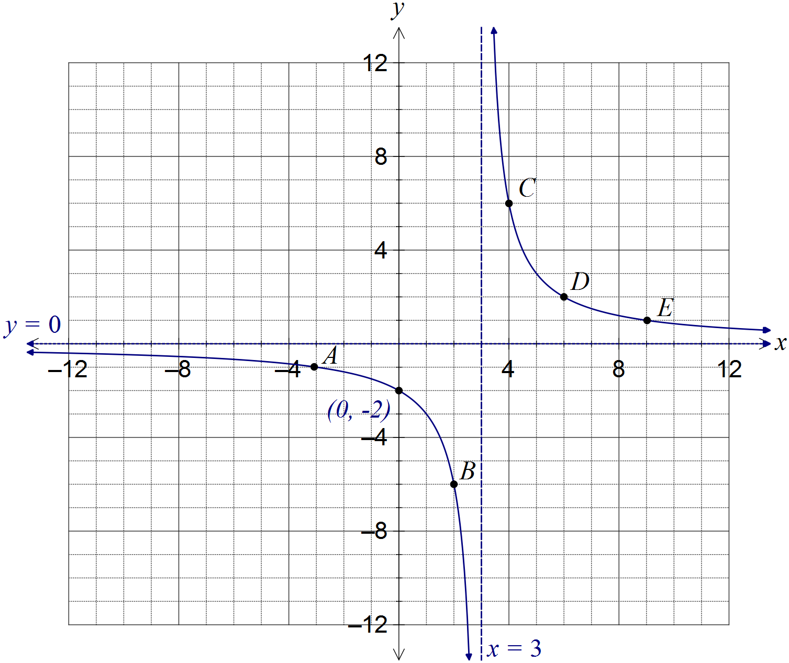

|  |
| --- |
| **Solution** |
| See graph |
| **Specific behaviours** |
| ✓ curves approach vertical asymptote, which is shown with equation  ✓ curves approach horizontal asymptote, without hooking upwards  ✓ coordinates of y-intercept shown  ✓ smooth curve passing through at least 3 of A, B, C, D or E |

(c) The graph of  is dilated vertically by a scale factor of 4 followed by a translation of three units to the right. Determine the coordinates of the y-intercept of the transformed graph. (2 marks)

|  |
| --- |
| **Solution** |
| Transforms the point (-3, -1) to (-3, -4) to (0, -4)  or |
| **Specific behaviours** |
| ✓ applies dilation  ✓ applies translation |

Question 12 (8 marks)

(a) A 3.6 m long ladder first rests against a vertical wall BC, making an angle of 70° with the horizontal ground. The ladder is rotated in a vertical plane about E to rest against wall AD, reaching a point 2.6 m above the ground.

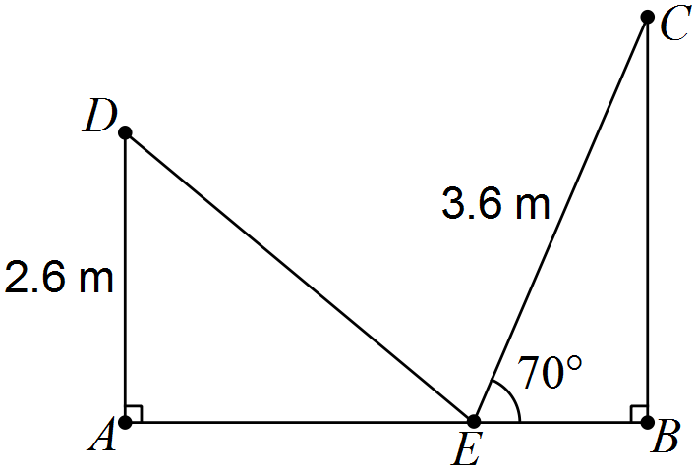

Showing use of trigonometry, determine

(i) the angle through which the ladder was rotated. (2 marks)

|  |
| --- |
| **Solution** |
|  |
| **Specific behaviours** |
| ✓ calculates angle in triangle  ✓ determines rotation angle |

(ii) the distance AB. (2 marks)

|  |
| --- |
| **Solution** |
|  |
| **Specific behaviours** |
| ✓ determines AE  ✓ determines EB and adds to get AB |

(iii) the distance DC. (2 marks)

|  |
| --- |
| **Solution** |
|  |
| **Specific behaviours** |
| ✓ uses cosine rule  ✓ determines length |

(b) A thin metal plate in the shape of an equilateral triangle has an area of 330 cm. Determine the side length of the triangle. (2 marks)

|  |
| --- |
| **Solution** |
| Let side length be x. Then |
| **Specific behaviours** |
| ✓ uses area formula  ✓ determines length |

Question 13 (8 marks)

(a) In a group of 47 people, 6 had surnames beginning with A, 5 had first names beginning with A and 38 had neither name beginning with A. Determine the probability that a randomly chosen person from the group

(i) has both names beginning with A. (2 marks)

|  |
| --- |
| **Solution** |
|  |
| **Specific behaviours** |
| ✓ uses probability rule  ✓ determines correct probability |

(ii) only has a first name beginning with A. (1 mark)

|  |
| --- |
| **Solution** |
|  |
| **Specific behaviours** |
| ✓ determines probability |

(iii) only has a surname beginning with A, given that either their first name or surname begins with A. (2 marks)

|  |
| --- |
| **Solution** |
|  |
| **Specific behaviours** |
| ✓ uses conditional probability  ✓ determines probability |

(b) In the population as a whole, it was thought that 3% had surnames beginning with A, 4% had first names beginning with A and 0.15% had both names beginning with A. Estimate how many people in a group of 2000 will have neither name beginning with A.

(3 marks)

|  |
| --- |
| **Solution** |
|  |
| **Specific behaviours** |
| ✓ calculates union  ✓ calculates complement  ✓ calculates number |

Question 14 (7 marks)

A function and a relation have been graphed on the axes below.

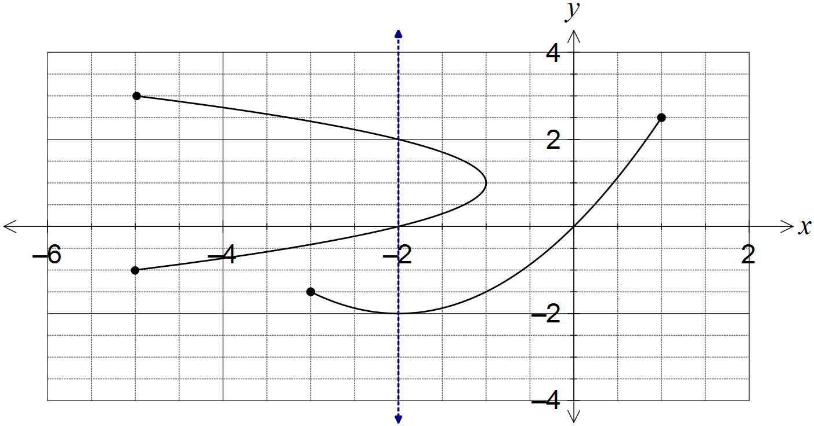

(a) Draw the line  on the graph and explain how it can be used to identify the relation. (2 marks)

|  |
| --- |
| **Solution** |
| See line on graph.  Vertical line cuts the relation more than once, but the function just once. |
| **Specific behaviours** |
| ✓ draws vertical line  ✓ explains vertical line test |

(b) State the domain and range of the function. (2 marks)

|  |
| --- |
| **Solution** |
|  |
| **Specific behaviours** |
| ✓ states domain  ✓ states range |

(c) The relation can be expressed in the form . Determine the values of the constants a and b. (3 marks)

|  |
| --- |
| **Solution** |
| When . |
| **Specific behaviours** |
| ✓ selects suitable point from relation  ✓ determines a  ✓ determines b |

Question 15 (9 marks)

A sensor was fitted to the tip of a blade on a wind turbine to measure the height, h metres, of the blade above the ground. The height was observed to vary according to the function  , where  is the time in seconds since measurements began.

(a) Determine the height of the blade tip above the ground when . (1 mark)

|  |
| --- |
| **Solution** |
|  |
| **Specific behaviours** |
| ✓ calculates height |

(b) Sketch the graph of  on the axes below for . (4 marks)

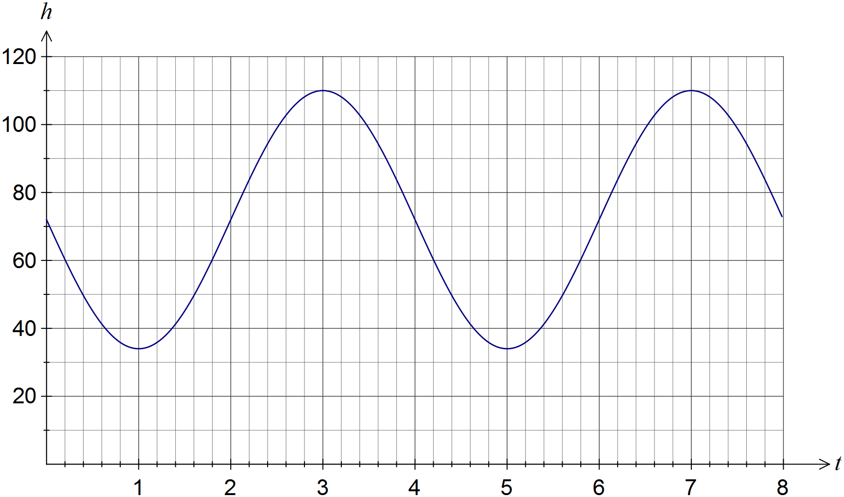

|  |
| --- |
| **Solution** |
| See graph |
| **Specific behaviours** |
| ✓  ✓ minimums at (1, 34) and (5, 34)  ✓ maximums at (3,110) and (7, 110)  ✓ smooth curve through above points, no abrupt 'corners' |

(c) How long does the blade take to rotate once? (1 mark)

|  |
| --- |
| **Solution** |
| 4 seconds |
| **Specific behaviours** |
| ✓ states time |

(d) Assuming the blade continues to rotate in this manner, determine the percentage of time during which the blade tip is at least 90 m above the ground. (3 marks)

|  |
| --- |
| **Solution** |
|  |
| **Specific behaviours** |
| ✓ solves for height of 90 m  ✓ determines interval above 90  ✓ determines percentage |

Question 16 (8 marks)

A selection of four representatives is to be made from eleven students, comprising six girls and five boys. Determine

(a) the number of ways in which this can be done. (2 marks)

|  |
| --- |
| **Solution** |
|  |
| **Specific behaviours** |
| ✓ uses combination  ✓ evaluates |

(b) the number of selections that contain the same number of girls and boys. (2 marks)

|  |
| --- |
| **Solution** |
|  |
| **Specific behaviours** |
| ✓ uses multiplication of combinations  ✓ evaluates |

(c) the probability that three of the representatives chosen are girls. (2 marks)

|  |
| --- |
| **Solution** |
|  |
| **Specific behaviours** |
| ✓ evaluates ways to choose three girls and one boy  ✓ expresses as probability |

(d) the probability that more boys than girls are chosen. (2 marks)

|  |
| --- |
| **Solution** |
|  |
| **Specific behaviours** |
| ✓ evaluates ways to choose 3 or 4 boys  ✓ expresses as probability |

Question 17 (9 marks)

(a) The diagram below shows the five graphs , , ,  and , where a, b, c and d are constants.

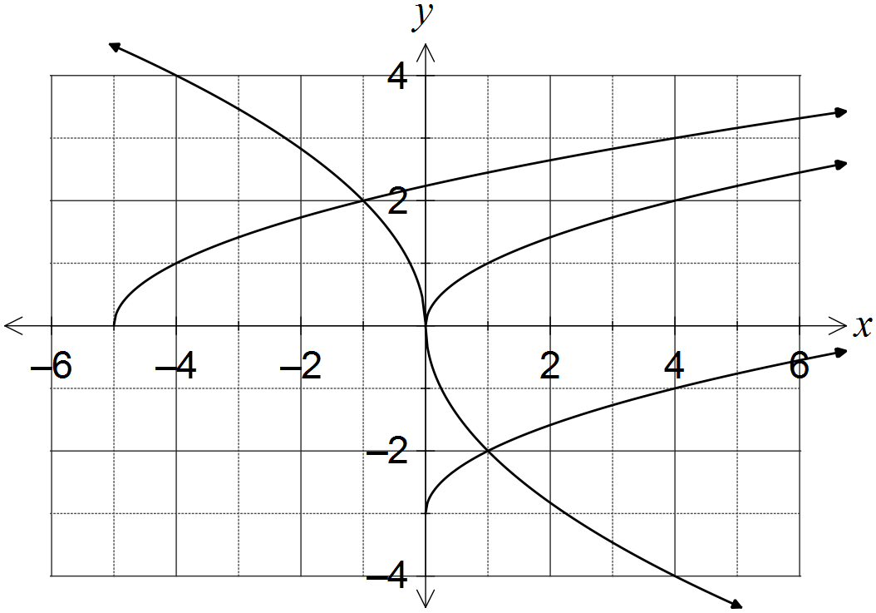

(i) Determine . (1 mark)

|  |
| --- |
| **Solution** |
|  |
| **Specific behaviours** |
| ✓ determines correct value |

(ii) Determine the values of the constants a, b, c and d. (4 marks)

|  |
| --- |
| **Solution** |
| a is vertical translation:  b is horizontal translation:  c is vertical dilation and reflection in x-axis:  d is horizontal dilation and reflection in y-axis: |
| **Specific behaviours** |
| ✓ determines a  ✓ determines b  ✓ determines c  ✓ determines d |

(b) Describe two transformations that will transform the graph of  to:

(i) . (2 marks)

|  |
| --- |
| **Solution** |
| Translate original graph 1 unit right and 2 units downwards (in either order) |
| **Specific behaviours** |
| ✓ horizontal translation  ✓ vertical translation |

(ii) . (2 marks)

|  |
| --- |
| **Solution** |
| Reflect in x-axis and dilate vertically by scale factor 5 (in either order) |
| **Specific behaviours** |
| ✓ reflection  ✓ dilation |

Question 18 (8 marks)

The events  and  are such that  and .

(a) Determine  in each of the following cases.

(i)  and  are mutually exclusive. (1 mark)

|  |
| --- |
| **Solution** |
|  |
| **Specific behaviours** |
| ✓ determines probability |

(ii) . (2 marks)

|  |
| --- |
| **Solution** |
|  |
| **Specific behaviours** |
| ✓ uses probability law  ✓ determines probability |

(iii) . (2 marks)

|  |
| --- |
| **Solution** |
|  |
| **Specific behaviours** |
| ✓ determines  ✓ determines probability |

(b) Are  and  independent in any of the above three cases? Justify each decision.

(3 marks)

|  |
| --- |
| **Solution** |
| (i) No -  (ii) Yes -  (iii) No - |
| **Specific behaviours** |
| ✓ correct response with reason for (i)  ✓ correct response with reason for (ii)  ✓ correct response with reason for (iii) |

Question 19 (8 marks)

(a) Given that , where , show how to determine the exact value of

(i) . (2 marks)

|  |
| --- |
| **Solution** |
|  |
| **Specific behaviours** |
| ✓ uses right triangle to determine hypotenuse  ✓ states exact value |

(ii) . (2 marks)

|  |
| --- |
| **Solution** |
|  |
| **Specific behaviours** |
| ✓ considers sign of cos in 2nd quadrant  ✓ states exact value |

(iii) . (2 marks)

|  |
| --- |
| **Solution** |
|  |
| **Specific behaviours** |
| ✓ substitutes into double angle identity  ✓ simplifies correctly |

(b) Determine the two smallest solutions to the equation  for .

(2 marks)

|  |
| --- |
| **Solution** |
| Using CAS: , or: |
| **Specific behaviours** |
| ✓ determines one solution  ✓ determines both solutions |

Question 20 (7 marks)

(a) Determine the exact area of a sector enclosed by an arc of length 42 cm in a circle of radius 12 cm. (2 marks)

|  |
| --- |
| **Solution** |
|  |
| **Specific behaviours** |
| ✓ calculates angle  ✓ calculates exact area |

(b) In the diagram below, BC is a tangent to the circle with diameter AB and centre O.

Given that  cm and  cm, determine the shaded area. (5 marks)

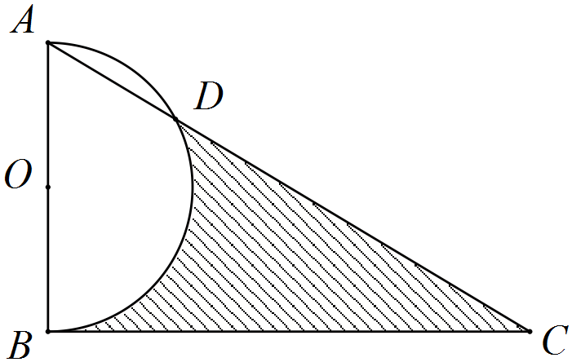

|  |
| --- |
| **Solution** |
|  |
| **Specific behaviours** |
| ✓ determines angle BAD  ✓ determines angle AOD  ✓ determines segment area  ✓ determines semicircle and triangle area  ✓ determines shaded area |

Additional working space

Question number: _________

Additional working space

Question number: _________

Additional working space

Question number: _________

Additional working space

Question number: _________

© 2016 WA Exam Papers. Rossmoyne Senior High School has a non-exclusive licence to copy and communicate this paper for non-commercial, educational use within the school. No other copying, communication or use is permitted without the express written permission of WA Exam Papers.